Rhetorical Devices
The following devices are tools that authors use to communicate with their readers. We need to be able to identify these devices in what read, and we also need to be able to discuss their purpose (why did the author include the device?) and their effectiveness (did the device help your understanding of the author’s message?)

- Diction – this refers to the author’s word choice. The word choice a writer makes determines the reader's reaction to the object of description, and contributes to the author's style and tone.
Example:
Formal Diction | Casual Diction | Slang (very informal)
are not angry | aren't mad | ain't ticked

Positive | Negative
pruning the bushes | slashing at the bushes
the politician's stance | the politician's spin

- Irony – Typically it is the opposite of what we expect. The man’s comment in the picture below is ironic because they are about to be executed. It definitely gets better than that!
Example:
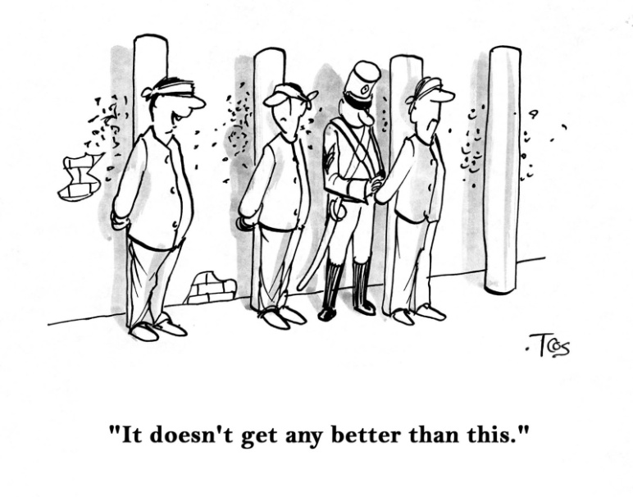
- Hyperbole - exaggerated statements or claims not meant to be taken literally.
Example:
I’m so hungry I could eat a horse!
He has the weight of the world on his shoulders.
- Imagery - A common term of variable meaning, imagery includes the "mental pictures" that readers experience with a passage of literature. Imagery is not limited to visual imagery; it also includes your other senses: sounds, smells, tastes, and touches.
Example:
The crimson liquid spilled from the neck of the white dove, staining and matting its pure, white feathers.
The shadows crisscrossed the rug while my cat stretched languidly in one of the patches of sun.
- Anecdote - a short and interesting story or an amusing event often proposed to support or demonstrate some point and make readers and listeners laugh.
Example:
Before Christmas morning breakfast, parents tell their children about their very first Christmas together.
High school students go around the classroom telling their favorite memories from elementary school.

- Allusioin - a reference in a literary work to a person, place, or thing in history or another work of literature. Allusions are often indirect or brief references to well-known characters or events.
Example: Taylor Swift’s Song
Cause you were Romeo, I was a scarlet letter
And my daddy said stay away from Juliet
But you were everything to me
I was begging you please don't go and I said
- Analogy - A literary analogy is a comparison in which the subject is compared point by point to something far different, usually with the idea of clarifying the subject by comparing it to something familiar. Analogies can provide insights and also imply that the similarities already present between the two subjects can mean even more similarities.
Example:
Life is one long scary roller coaster.
- Rhetorical Question - A question to which no answer is expected, often used for rhetorical effect.
Example:
Is the pope catholic?
Time will pass. Will you?
- Repetition - Repetition is a major rhetorical strategy for producing emphasis, clarity, amplification, or emotional effect.
Example:
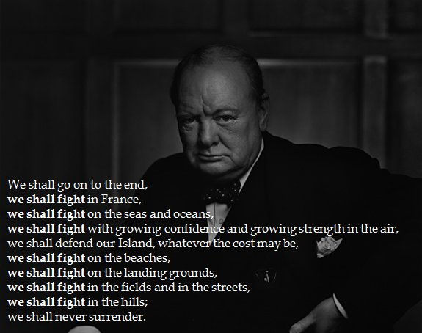
- Figurative Language - uses words or expressions with a meaning that is different from the literal interpretation.
Simile is a comparison using like or as. It usually compares two unlike objects.
Example: His feet are as big as boats. Feet and boats are being compared.

Metaphor states that one thing is something else. It is a comparison, but does NOT use like or as to make the comparison.
Example: Her hair is silk. Hair and silk are being compared.

Personification is giving human qualities, feelings, actions, or characteristics to inanimate (not living) objects.
Example: The house stared at me with looming eyes. The verb, stared, is a human action. A house is a non-living object. Therefore, we have a good example of personification.

Onomatopoeia is the imitation of natural sounds in word form. These words help us form mental pictures, or visualize, things, people, or places that are described. Sometimes a word names a thing or action by copying the sound.
Example: Bong! Hiss Buzz!

Symbolism occurs when one thing stands for or represents something else.
Example: The dove symbolizes peace.

